Booting is the process of switching on a computer. Two types of booting are cold booting and warm booting.

*Six steps of the booting process are*[*BIOS*](https://sciencerack.com/bios/)*and Setup Program, The Power-On-Self-Test (POST), The*[*Operating System*](https://sciencerack.com/types-of-operating-system/)*Loads, System Configuration, System Utility Loads, and Users Authentication.*

*Types of Booting*

Booting is the process of switching on the computer and starting the operating system.

When a computer is switched on, The boot process loads the operating system into the main [memory](https://sciencerack.com/types-of-computer-memory-with-differences/) (RAM) installed inside it.

Types of computer booting are Cold Booting And Warm Booting.

* Cold Boot: when the user switches on a computer after it has been power off completely,
* Warm Boot: when the user restarts the computer.

When the booting process takes place, it copies kernel and important instructions of an [operating system](https://sciencerack.com/types-of-operating-system/) from hard disk to main [memory](https://sciencerack.com/types-of-computer-memory-with-differences/) (RAM). The kernel is the most important part of the operating system that manages memory and devices, maintains the computerclock,startsapplications.  
It assigns compute resources like devices, programs, [data, and information](https://sciencerack.com/difference-between-data-and-information/) also. The [kernel](https://en.wikipedia.org/wiki/Kernel_(operating_system))also remains in [memory](https://sciencerack.com/types-of-computer-memory-with-differences/) permanently when the computer starts.

## Steps In the Booting Process

Booting is the process of switching on the computer and starting the operating system. 6 steps in the booting process are [BIOS](https://sciencerack.com/bios/) and Setup Program, The Power-On-Self-Test (POST), The [Operating System](https://sciencerack.com/types-of-operating-system/)Loads, System Configuration, System Utility Loads, and Users Authentication.

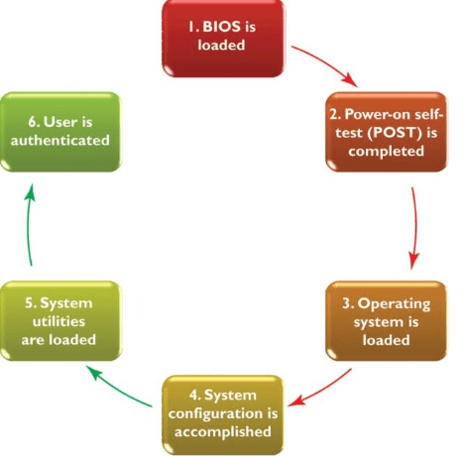

* 1: [BIOS](https://sciencerack.com/bios/) and Setup Program
* 2: The Power-On-Self-Test ([POST](https://sciencerack.com/power-on-self-test/))
* 3: The Operating System (OS) Loads
* 4: System Configuration
* 5: System Utility Loads
* 6: Users Authentication

 Booting Process Of Computer Step By Step

Here is the explanation of the booting process steps for more clarity.

Step 1: [BIOS](https://sciencerack.com/bios/) and Setup Program

BIOS stands for basic input/output system. The BIOS is the first software program that runs when you start up your system. The first time you press the power button on your computer, the Basic Input / Output System goes into action, and the [booting process](https://sciencerack.com/booting-process/) will begin.

Setup program: a special program containing settings to control hardware.  Furthermore,  the program can only be accessed while the [BIOS](https://sciencerack.com/bios/) information is visible.

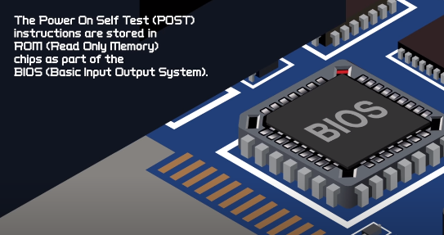

***Step 2: The Power-On-Self-Test (POST)***

* POST (Power-On Self-Test): a series of tests conducted on the [computer’s main memory,](https://sciencerack.com/types-of-computer-memory-with-differences/) input/output devices, disk drives, and the hard disk.
* BIOS conducts Power-On-Self-Test to check the input/ output system for operability.
* The computer will produce a beeping sound if any problem occurs. An error message will also appear on the monitor

***Step 3: The Operating System (OS) Loads***

BIOS  searches for the [operating system](https://sciencerack.com/types-of-operating-system/).

* In this step, the operating system’s kernel is also loaded into the [computer’s memory.](https://sciencerack.com/types-of-computer-memory-with-differences/)
* The operating system takes control of the computer and begins loading system configuration information.

***Step 4: System Configuration***

* Registry: a [database](https://sciencerack.com/database/) to store information about peripherals and software
* Peripheral: a device connected to a computer
* Drive: a [utility program](https://sciencerack.com/types-of-utility-programs/) that makes peripheral devices function properly
* The [operating system’s](https://sciencerack.com/types-of-operating-system/) registry configures the system.
* In this step, drivers are also loaded into [memory](https://sciencerack.com/types-of-computer-memory-with-differences/).

***Step 5: System Utility Loads***

* System utilities are loaded into [memory](https://sciencerack.com/types-of-computer-memory-with-differences/).
* Volume control
* Antivirus software
* PC card unplugging utility

***Step 6: Users Authentication***

* Authentication or user login occurs
* Username
* Password

The above-mentioned steps play an important role in booting a computer. After all this process, the user interface starts, enabling user interaction with the computer and its programs also.